**Social Media user Experiment over University of Barishal**

Economics: Statistical Methods

**Submitted by**

Apurba Voumik

Department of Economics

University of Barishal

**Submitted to**

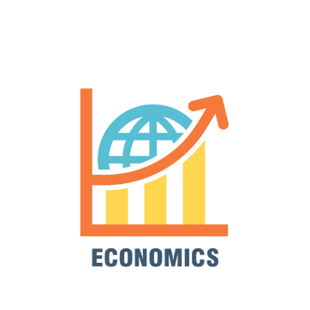

**University of Barishal**

Table of Contents

1.Abstract 3

2.Introduction 3

3.Challenges 4

3.1 Participant Related Challenges 4

3.2 Technical Challenges 4

3.3 Logistical Challenges 4

3.4 Emotional and Mental Challenges (positive) 5

4.Literature Review 5

5. Methods 6

5.1 Data Collection: 6

5.2 Pivot Table: 7

5.3 Questions: 7

5.4 Analysis and Visualization: 7

6.Result and Discissions 8

6.1 Questions from Pivot table: 8

6.2 A sample picture of pivot table: 9

6.3 Answers including questions are shown below: 10

Gender-Based Analysis 15

Comparison Between Genders 15

**Detailed Analysis** 17

**Implications** 17

7.Conclusion 18

8.Reference 18

# 1.Abstract

This study explores the social media usage patterns and their effects on individuals within the Barishal University community, focusing on students’ interactions with various platforms such as Facebook, YouTube, Instagram, WhatsApp, and LinkedIn. A total of 119 participants (30 female, 45 male) were surveyed to assess the amount of time spent on social media, primary activities, frequency of notifications checking, and the psychological and physical consequences associated with social media engagement. Common activities include browsing content, posting photos/videos, and messaging friends/family. Notifications are frequently checked, with many respondents indicating occasional feelings of anxiety when unable to access social media. The majority report experiencing stress, anxiety, or physical fatigue such as eyestrain, difficulty sleeping, and lack of focus after prolonged use. Social comparison and FOMO (Fear of Missing Out) are also recurring themes, with many participants admitting to comparing themselves to others on social media. Despite these negative effects, some individuals reported that social media has strengthened their relationships, while others noted a weakening of social connections. Overall, the study suggests a complex relationship between social media usage, well-being, and social interactions among university students.

# ****2.Introduction****

In the digital age, social media platforms have become integral to everyday life, especially among university students who use them for various purposes, ranging from social interaction to academic engagement. Barishal University, like many educational institutions, is home to a diverse student body, many of whom actively engage with social media platforms such as Facebook, YouTube, Instagram, WhatsApp, and LinkedIn. These platforms offer a convenient space for students to stay connected, share content, follow news and events, and communicate with peers. However, as social media use has grown, concerns have emerged about its impact on students' mental health, well-being, and academic performance.

This study, titled "Social Media User Experiment Over Barishal University," aims to investigate the patterns and effects of social media use among students at Barishal University. By examining the amount of time spent on social media, the activities students engage in, and the emotional and physical consequences of prolonged use, the study seeks to provide insights into how these platforms influence students’ daily lives. Additionally, the research explores the psychological effects, such as anxiety, stress, and social comparison, as well as how social media affects students' relationships and self-esteem.

Through this study, we hope to better understand the role of social media in shaping the experiences of Barishal University students, shedding light on both the positive and negative consequences of its pervasive use in academic and social settings. By identifying patterns and areas of concern, the findings may contribute to a broader discussion on managing social media usage and its impact on students' overall well-being.

# 3.Challenges

Collecting data for a survey on social media usage presented a variety of challenges, ranging from logistical and technical issues to participant-related difficulties. Despite careful planning, each step of the data collection process required adaptability and problem-solving to ensure accurate and reliable results. The outlines is the key challenges faced during the process and the strategies used to overcome them.

## 3.1 Participant Related Challenges

One of the most significant challenges encountered was participant reluctance. Many individuals were hesitant to take part in the survey, often citing privacy concerns or a lack of interest in discussing their social media habits. Convincing potential respondents to participate required clear communication about the purpose of the study and assurances of confidentiality.

Additionally, incomplete or inaccurate responses posed another hurdle. Some participants either skipped questions or provided inconsistent answers that contradicted other responses. This issue necessitated follow-up communication to clarify their inputs, which was time-consuming and sometimes led to delays in the data collection process. Another concern was the potential bias in responses, as some participants may have given socially desirable answers rather than their genuine experiences, potentially affecting the accuracy of the data.

## 3.2 Technical Challenges

Technical issues also played a significant role in complicating the data collection process. One of the primary challenges was the occurrence of data entry errors. Manually entering survey responses into a spreadsheet introduced occasional typographical mistakes, which required thorough data cleaning and verification to maintain data integrity.

Another technical challenge was managing file formats. Participants used a variety of devices and platforms to complete the survey, resulting in data that needed to be converted and standardized for analysis. This process was both time-consuming and prone to errors, particularly when dealing with incompatible file formats or corrupted data.

## 3.3 Logistical Challenges

Logistical constraints further added to the complexity of data collection. A limited timeframe for conducting the survey made it difficult to reach a larger and more diverse sample size. It generally takes more than five days to collect the preceding data for making a pivot chart and report over it but I had to manage everything in this short period. Expanding the participant pool would have provided more comprehensive insights, but time restrictions limited the scope of data collection.

Scheduling conflicts with participants were another logistical obstacle. Coordinating with individuals who had busy schedules or were in different time zones often delayed the data collection process. Frequent rescheduling and follow-up reminders were necessary to ensure timely responses.

## 3.4 Emotional and Mental Challenges (positive)

Collecting data on sensitive topics, such as the psychological and emotional impact of social media, presented emotional challenges as well. Some participants shared personal experiences related to anxiety, stress, and self-esteem issues. Creating a safe and supportive environment for participants to express themselves required empathy and sensitivity. Ensuring their comfort and maintaining confidentiality were crucial to gaining their trust and obtaining honest responses.

# ****4.Literature Review****

Social media has become an essential part of daily life, particularly among university students. The rise of platforms like Facebook, Instagram, YouTube, WhatsApp, and LinkedIn has significantly influenced how students communicate, share content, and stay informed. Various studies have explored the impact of social media on students’ academic, social, and psychological well-being, highlighting both positive and negative outcomes.

One of the primary reasons for the widespread use of social media among students is its role in facilitating communication and social interaction. According to a study by Junco (2012), social media platforms enable students to maintain relationships, both with peers and family, and can also enhance collaborative learning and academic engagement. Platforms like Facebook and WhatsApp are particularly popular for staying connected with friends and participating in group discussions (Pempek, Yermolayeva, & Calvert, 2009). This connectivity is crucial for students who are away from home or live in university dorms, providing a sense of belonging and support.

However, while social media offers numerous benefits, research has also identified several negative consequences associated with its excessive use. One of the most commonly reported issues is its impact on mental health. Studies have shown that prolonged social media use can lead to increased feelings of anxiety, depression, and loneliness (Kuss & Griffiths, 2017). Social comparison, a phenomenon where individuals compare their lives or appearances with others online, has been identified as a significant contributor to these negative effects. Fardouly et al. (2015) found that young adults, particularly females, are more likely to experience body image concerns and low self-esteem as a result of comparing themselves to others on social media platforms.

Additionally, social media has been linked to disruptions in sleep patterns and decreased academic performance. A study by Lepp et al. (2015) found that heavy social media use is associated with poor sleep quality, primarily due to the blue light emitted by screens and the mental stimulation from constant notifications. Furthermore, excessive time spent on social media often leads to reduced attention and focus on academic tasks, with students spending less time on studies or research (Rosen et al., 2013). This phenomenon is particularly prevalent among university students, who juggle academic responsibilities and social media engagement.

The issue of FOMO (Fear of Missing Out) has also been widely discussed in literature. Studies suggest that FOMO can exacerbate the emotional toll of social media, causing users to feel left out or disconnected from social events or activities (Przybylski et al., 2013). This feeling of being excluded or missing important social events can contribute to stress and anxiety, particularly when users perceive that their peers are leading more exciting or fulfilling lives.

On a positive note, social media can strengthen relationships, both personally and professionally. According to a study by Manago et al. (2012), online platforms can facilitate communication and social support, especially among individuals in long-distance relationships or those with limited social networks. In the context of academic life, platforms like LinkedIn can provide students with valuable networking opportunities, fostering connections that may benefit their future careers.

Existing literature highlights the dual nature of social media usage among university students. While it offers significant social and academic advantages, it also presents challenges related to mental health, sleep, and academic performance. The balance between these positive and negative effects remains an important area for research, particularly as social media continues to evolve and shape the lives of students worldwide. This study at Barishal University will contribute to this ongoing conversation by exploring how social media impacts students' experiences, well-being, and relationships.

# 5. Methods

The purpose of this study was to explore the social media usage patterns and their impact on students at Barishal University. To achieve this, data was collected from a sample of 119 university students, each with varying levels of social media engagement. The data gathered was used to create a comprehensive analysis through pivot tables, statistical questions, and visual representations, such as graphs and charts. The following section outlines the methodology used in the study, including data collection, analysis techniques, and the tools employed to present the results.

## 5.1 Data Collection:

The data was collected through a structured questionnaire(using userform) that included questions regarding participants' social media usage habits, their primary activities on social media, emotional responses to usage, and any psychological or physical effects they experienced. The respondents were also asked to assess how social media impacted their relationships, self-esteem, and overall well-being. The survey covered the following key areas:

* **Demographics:** Age, gender, and employment status of participants.
* **Social Media Usage:** Platforms used, hours spent daily on social media, and frequency of checking notifications.
* **Primary Activities on social media:** Browsing content, posting photos/videos, messaging friends/family, engaging in discussions, and following news/events.
* **Psychological Effects:** Feelings of anxiety when unable to check accounts, experiences of FOMO, social comparison, and stress/anxiety after usage.
* **Physical and Emotional Impact:** Effects such as eyestrain, lack of focus, and difficulty sleeping.
* **Relationship Impact:** Whether social media usage had strengthened or weakened their relationships.

## 5.2 Pivot Table:

The data collected was organized into a pivot table, which helped categorize and analyze the responses based on key factors such as age, gender, and social media usage patterns. The pivot table allowed for easy comparison of the followings:

* Uses of social media platforms.
* Primary activities engaged in on social media.
* Hours of spending on social media daily
* Frequency of checking notifications.
* Emotional and psychological responses associated with social media usage.
* Physical effects experienced after prolonged use of social media.

By summarizing the data in this way, it became easier to identify trends and patterns among different demographic groups (e.g., age, gender), as well as to see how social media affected various aspects of students' lives.

## 5.3 Questions:

Based on the data from the survey, the research questions were developed to guide the analysis. The questions are given at the **Result and Discussion** section.

## 5.4 Analysis and Visualization:

The data was analyzed using descriptive statistics and visualized through various graphs and charts to provide a clearer understanding of the trends and patterns observed. This included:

* **Bar Graphs:** To show the distribution of time spent on social media across different age groups and platforms used.
* **Line Graphs:** To represent the frequency of social media usage over time and the frequency of checking notifications.
* **Pie Charts:** To analysis the relationship among different frequencies of social media uses.

These visual tools allowed for a more comprehensive understanding of the relationship between social media usage and its psychological, emotional, and social effects on the students or individuals of Barishal University.

# 6.Result and Discissions

This section shows the questions generated from the pivot table and their results as jpeg, txt and graph format. Father explanations are given below:

## 6.1 Questions from Pivot table:

1. Collect the Employment status of female and male individuals who are using social media. Show them on pie chart.
2. What is the amount of time spent on social media daily across different age groups?
3. How does social media usage vary by gender?
4. What are the most common primary activities on social media (e.g., browsing content, posting photos/videos, messaging friends/family) for different age groups? Explain graphically too.
5. How often do individuals check their social media notifications by gender and age group?
6. Do individuals experience anxiety when they are unable to check social media, and how does this vary by gender and age group?
7. How frequently do individuals compare their life or appearance to others on social media, based on age and gender?
8. What is the relationship between time spent on social media and reported feelings of stress or anxiety?
9. How does social media usage impact self-esteem across different age groups and genders?
10. What are the most common physical or mental effects reported after prolonged social media use (e.g., difficulty sleeping, eyestrain, physical fatigue)?
11. Does social media usage strengthen or weaken relationships, and how does this vary by age and gender? Show in graphical form.
12. How do mood changes after extended social media use vary by age group and gender?
13. How often do individuals experience feelings of depression or sadness after viewing posts or images on social media, based on age and gender?
14. Do individuals believe social media raises awareness about mental health issues, and how does this perception vary by age and gender?
15. How does the amount of time spend on social media correlate with the frequency of checking notifications? Explain in percentage.
16. Is there a correlation between the primary activities on social media and the feeling of stress or anxiety?
17. Do you believe that social media raises awareness about mental health issues on self-esteem and mental health? Explain graphically also.

## 6.2 A sample picture of pivot table:

## 6.3 Answers including questions are shown below:

|  |  |  |  |
| --- | --- | --- | --- |
| Count of Gender | Gender |  |  |
| Employment status | Female | Male | Grand Total |
| Employed |  | 32 | 32 |
| Housewife | 1 |  | 1 |
| Intern Doctor |  | 2 | 2 |
| Student | 28 | 44 | 72 |
| Unemployed | 3 | 7 | 10 |
| Grand Total | 32 | 85 | 117 |

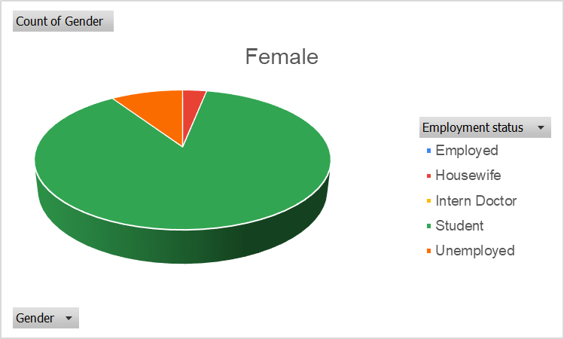**Question 1: Collect the Employment status of female and male individuals who are using social media. Show them on pie chart**.

The Table and Graph explains the individuals who are using social media by variations of different employment status. The dataset categorizes individuals into five distinct employment statuses: Employed, Housewife, Intern Doctor, Student, and Unemployed. Each category is further divided by gender, offering a detailed perspective on how different groups participate in social media. The total number of participants in the dataset is 117, comprising 32 females and 85 males.

#### ****Employment Status Breakdown****

Among the different employment statuses, **students** constitute the largest group of social media users. With **28 females** and **44 males**, the student category represents 61.5% of the total users, indicating that younger individuals, often students, are the most active demographic on social platforms.

In contrast, the **employed** category is significantly smaller, with only 3 male users and no female representation. This could suggest that working professionals, at least within this dataset, may have less time or interest in social media compared to students. Similarly, the **intern doctor** group is small, with only 2 males and no females, perhaps reflecting the demanding nature of medical internships, which might limit their social media engagement.

Another noteworthy observation is the presence of only **one housewife**, highlighting the minimal representation of this group in the dataset. Lastly, the **unemployed** category includes **3 females** and **7 males**, indicating that those who are not currently employed still maintain a presence on social media.

With males being the dominant users in this dataset. Additionally, students emerge as the most active group, suggesting that social media is particularly popular among younger, possibly tech-savvy individuals. These insights offer a valuable understanding of the demographics of social media users, shedding light on how different social groups engage with digital platforms.

**Question 5: How often do individuals check their social media notifications by age group?**

|  |  |  |  |  |  |
| --- | --- | --- | --- | --- | --- |
| Count of How often do you check social media notifications? | Column Labels |  |  |  |  |
| Row Labels | A few times a day | Every few minutes | Hourly | Once a day | Grand Total |
| 18-24 | 15 | 10 | 28 | 1 | 54 |
| 25-34 | 21 | 10 | 23 |  | 54 |
| 35-44 |  |  | 2 |  | 2 |
| 45-54 | 1 |  | 1 | 2 | 4 |
| Above 55 | 1 |  |  | 1 | 2 |
| under 18 | 1 |  |  |  | 1 |
| Grand Total | 39 | 20 | 54 | 4 | 117 |

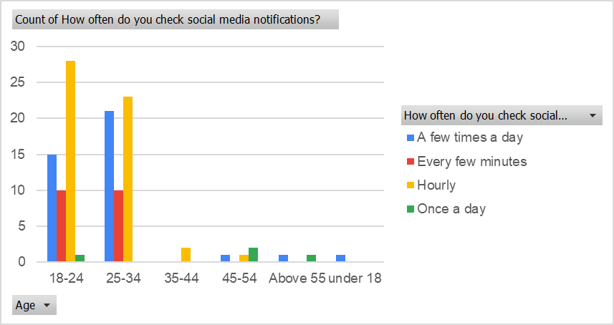

The table and chart illustrate how frequently individuals from different age groups check their social media notifications. The data is categorized into four frequency levels: a few times a day, every few minutes, hourly, and once a day.

**Key Observations:**

1. **18-24 Age Group:**
   * This group shows high engagement, with **15 individuals** checking notifications a few times a day.
   * **10 individuals** check every few minutes, and **28** check hourly, making it the most active age group overall.
2. **25-34 Age Group:**
   * This group has the highest engagement, with **21 individuals** checking a few times a day and **23** checking hourly.
   * **10 individuals** check every few minutes, indicating a high level of social media interaction.
3. **35-44 Age Group:**
   * Engagement significantly drops in this group, with only **1 individual** checking hourly and 2 individuals once a day.
4. **45-54 and Above 55 Age Groups:**
   * Minimal engagement is observed in these groups, with only **1 individual** checking hourly or once a day in each category.
5. **Under 18:**
   * This group has very low engagement, with just **1 individual** checking notifications hourly and another once a day.

The **18-24** and **25-34** age groups are the most active on social media, frequently checking their notifications, while older age groups show significantly less engagement. This trend reflects the strong connection between younger age groups and social media usage.

**Question10: What are the most common physical or mental effects reported after prolonged social media use?**

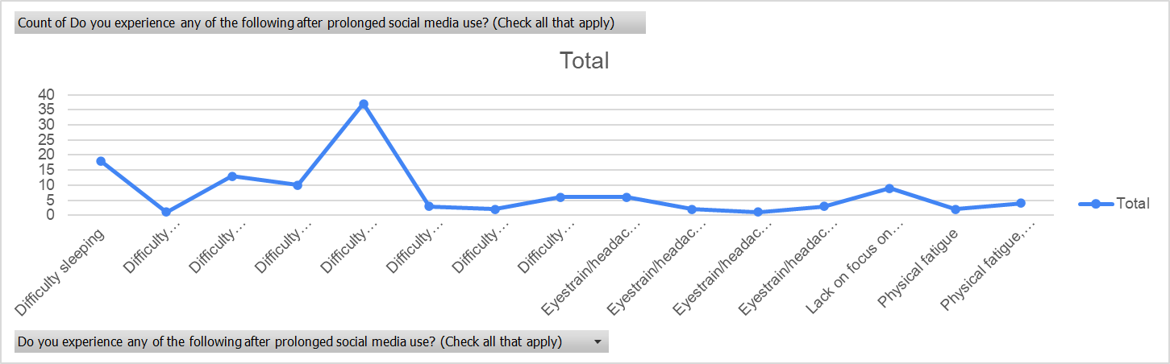

The table and chart highlight the physical and mental effects experienced by individuals after prolonged use of social media. The data reveals various issues related to health and focus, with some effects being more prevalent than others.

**Key Observations:**

1. **Difficulty Sleeping:**  
   This is a significant issue, with 18 individuals reporting it as a standalone effect and 13 experiencing it in combination with other symptoms like eyestrain and lack of focus. It is one of the most frequently cited problems.
2. **Lack of Focus on Tasks:**  
   A notable number of individuals (37) reported that prolonged social media use negatively impacts their ability to concentrate on tasks, either as a standalone issue or in combination with other effects.
3. **Eyestrain and Headaches:**  
   This is another common problem, with several individuals (10) mentioning it alone and 13 experiencing it alongside other symptoms such as difficulty sleeping and fatigue.
4. **Physical Fatigue:**  
   Reported by 9 individuals, physical fatigue appears both as a sole issue and in combination with eyestrain and lack of focus.
5. **Combined Effects:**  
   Many individuals reported experiencing multiple symptoms simultaneously, such as:
   * Difficulty sleeping, eyestrain, and lack of focus.
   * Physical fatigue, eyestrain, and concentration issues**.**

The most frequently reported effects of prolonged social media use are lack of focus on tasks, difficulty sleeping, and eyestrain/headaches. These findings suggest that excessive social media usage can significantly impact both mental clarity and physical well-being, emphasizing the need for mindful usage and regular breaks.

**Question 11: Does social media usage strengthen or weaken relationships, and how does this vary by age and gender? Show in graphical form.**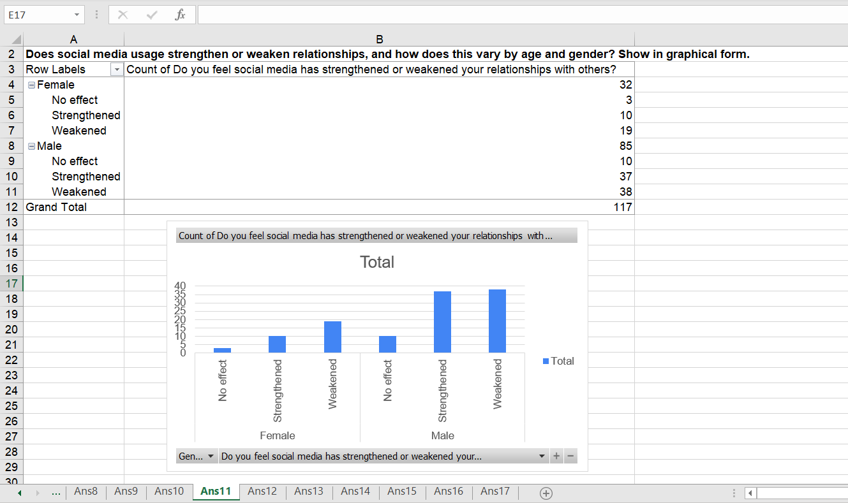

Out of the total 117 individuals surveyed:

* **40.17%** believe social media has strengthened their relationships.
* **48.72%** feel it has weakened their relationships.
* **11.11%** reported no effect.

### ****Gender-Based Analysis****

#### ****1. Female Perception****

* **Total Female Respondents:** 32 (27.35% of total)
  + **Strengthened:** 10 (31.25%)
  + **Weakened:** 19 (59.38%)
  + **No Effect:** 3 (9.38%)

##### **Observation:**

* A majority of females (nearly 60%) believe that social media has a **negative impact** on their relationships.
* Only 31.25% of females reported that social media has strengthened their connections, suggesting that women might experience more social strain from online interactions.

#### ****2. Male Perception****

* **Total Male Respondents:** 85 (72.65% of total)
  + **Strengthened:** 37 (43.53%)
  + **Weakened:** 38 (44.71%)
  + **No Effect:** 10 (11.76%)

##### **Observation:**

* Males show a more **balanced perspective**, with a nearly equal percentage perceiving social media as either strengthening (43.53%) or weakening (44.71%) their relationships.
* A smaller percentage (11.76%) of males report no noticeable effect.

### ****Comparison Between Genders****

1. **Females** are more likely to feel that social media weakens relationships, with nearly **59.38%** holding this view, compared to **44.71%** of males.
2. **Males** are relatively more optimistic, with **43.53%** indicating a positive impact, compared to only **31.25%** of females.
3. The percentage of respondents reporting **no effect** is slightly higher among males (11.76%) than females (9.38%).

Social media usage impacts relationships differently for males and females. **Females predominantly perceive it as weakening their social connections**, while **males are more divided**, with a substantial proportion acknowledging both positive and negative effects. This gender disparity highlights the importance of understanding how different groups experience social media to foster healthier digital interactions.

**Question 17: Do you believe that social media raises awareness about mental health issues on self-esteem and mental health? Explain graphically also.**



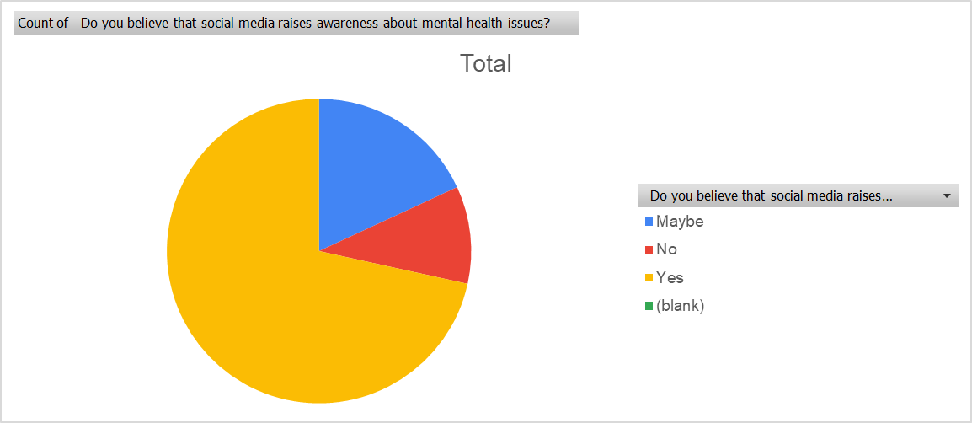

Social media platforms have become a powerful tool for spreading information and raising awareness about various social issues, including mental health. The data provides insights into how individuals perceive the role of social media in promoting mental health awareness.

Out of the 116 respondents:

* **83 individuals (71.55%)** believe that social media **raises awareness** about mental health issues.
* **21 individuals (18.10%)** are unsure, indicating a "Maybe."
* **12 individuals (10.34%)** do not believe that social media raises awareness.

**Detailed Analysis**

1. **Positive Perception (71.55%)**  
   The majority of respondents acknowledge the significant role social media plays in increasing awareness about mental health. This reflects the growing presence of mental health campaigns, discussions, and support networks across various platforms. Social media often serves as a space for individuals to share personal experiences, access resources, and engage in conversations that reduce stigma around mental health.
2. **Uncertainty (18.10%)**  
   A notable portion of respondents is unsure about the impact of social media on mental health awareness. This might suggest that while they recognize some efforts, they may not find them sufficient or impactful enough to fully acknowledge their role.
3. **Negative Perception (10.34%)**  
   A minority of respondents believe that social media does **not** effectively raise awareness about mental health issues. This group may feel that the content shared on social media is superficial, lacks credibility, or that the platforms are more focused on entertainment and less on meaningful social change.

**Implications**

The data suggests that social media is largely seen as a positive force in raising awareness about mental health. However, the presence of uncertainty and skepticism indicates room for improvement in how these platforms approach mental health advocacy. Ensuring accurate information, promoting credible resources, and encouraging authentic conversations could help increase the effectiveness of social media in this regard.

Social media is widely perceived as an effective tool for raising awareness about mental health, with over 70% of respondents affirming its positive impact. However, efforts to increase credibility and reach more skeptical audiences could further enhance its role in mental health advocacy.

# 7.Conclusion

The literature demonstrates that social media is a double-edged sword, capable of both enhancing and impairing mental health. While it fosters connectivity and awareness, its excessive use can lead to addiction, social comparison stress, and other adverse outcomes. By considering demographic and cultural factors and implementing targeted interventions, policymakers, educators, and healthcare providers can harness social media’s potential while mitigating its risks. Future research must continue to unravel the complexities of this relationship, ensuring that digital platforms contribute positively to societal well-being.

# 8.Reference

Junco, R. (2012). The relationship between frequency of Facebook use, participation in Facebook activities, and student engagement. Computers & Education, 58(1), 162–171.

Pempek, T. A., Yermolayeva, Y. A., & Calvert, S. L. (2009). College students' social networking experiences on Facebook. Journal of Applied Developmental Psychology, 30(3), 227–238.

Kuss, D. J., & Griffiths, M. D. (2017). Social networking sites and addiction: Ten lessons learned. International Journal of Environmental Research and Public Health, 14(3), 311.

Fardouly, J., Diedrichs, P. C., Vartanian, L. R., & Halliwell, E. (2015). Social comparisons on social media: The impact of Facebook on young women's body image concerns and mood. Body Image, 13, 38–45.

Lepp, A., Barkley, J. E., & Karpinski, A. C. (2015). The relationship between cell phone use, academic performance, anxiety, and satisfaction with life in college students. Computers in Human Behavior, 31, 343–350.

Rosen, L. D., Whaling, K., Carrier, L. M., Cheever, N. A., & Rokkum, J. (2013). The media and technology usage and attitudes scale: An empirical investigation. Computers in Human Behavior, 29(6), 2501–2511.

Przybylski, A. K., Murayama, K., DeHaan, C. R., & Gladwell, V. (2013). Motivational, emotional, and behavioral correlates of fear of missing out. Computers in Human Behavior, 29(4), 1841–1848.

Manago, A. M., Taylor, T., & Greenfield, P. M. (2012). Me and my 400 friends: The anatomy of college students’ Facebook networks, their communication patterns, and well-being. Developmental Psychology, 48(2), 369–380.

Pallant, J. (2020). SPSS Survival Manual: A Step-by-Step Guide to Data Analysis Using IBM SPSS (7th ed.). Routledge.

Field, A. (2018). Discovering Statistics Using IBM SPSS Statistics (5th ed.). Sage Publications.  
(Covers statistical analysis and data visualization techniques, including the use of pivot tables and various graph types.)